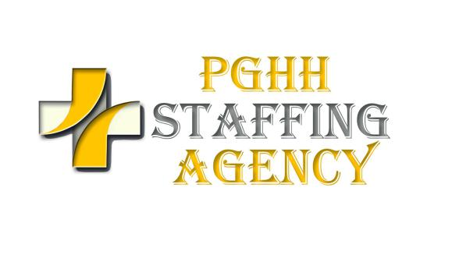
PSYCHIATRIC NURSING SKILLS CHECKLIST

0 = No Experience
1 = Perform infrequently (would require some supervision)
2 = Able to perform without any supervision
Section A | 0 | 1 | 2 |  | SECTION D | 0 | 1 | 2
CARE OF PATIENTS WITH: |  |  |  |  | Conducts or co-conducts group therapy sessions
assaultive behavior |  |  |  |  | Continual reassessment of patient; updating care plan
chemical dependency |  |  |  |  | Initial nursing intake interview, assessment and care plan
desire to fraternize with staff |  |  |  |  | Therapeutic communication skills
ECT |  |  |  |  | iV THERAPY
eating disorders |  |  |  |  | administration & monitoring of blood & blood products
hallucinations |  |  |  |  | heparin locks
manic disorder-acute phase |  |  |  |  | hyperalimentaion-maintainance & precautions
needs for limit setting |  |  |  |  | use of infusion pumps
rapid tranquilization |  |  |  |  | veni-puncture
restriction to isolation or seclusion |  |  |  |  | RESTRAINTS
SECTION B
seizure disorder |  |  |  |  | ambulatory cuffs
severe anxiety |  |  |  |  | full restraints
Schizophrenia |  |  |  |  | waist restraints
suicidal tendencies |  |  |  |  | Administering medications:
CARE OF PATIENT WITH SECONDARY MEDICAL PROBLEMS |  |  |  |  | IM
cardiac and/or pulmonary arrest |  |  |  |  | IM - Z – techniques
cardiac complications |  |  |  |  | IV
CHF |  |  |  |  | PO
foley catheter/catheter care |  |  |  |  | Rectal
Diabetes |  |  |  |  | sub-Q
IV therapy-starts and maintainance |  |  |  |  | Working knowledge of effective behavior modification techniques
tube feedings |  |  |  |  | Assessing needs of elderly psychiatric patient
pulmonary edema |  |  |  |  | Managing the patient with assaultive behavior
Oro-Naso-Pharynx suctioning |  |  |  |  | Use of open and closed seclusion
O2 therapy |  |  |  |  | Active participation in family counseling
ostomy care |  |  |  |  | Care of child psych patient
tracheostomy care |  |  |  |  | Care of adolescent psych patient
GENERAL |  |  |  |  | Care of adult psych patient
Admission of psychiatric patient |  |  |  |  | Care of the rape victim
Active participation in multi-disciplinary treatment planning |  |  |  |  | Care of the borderline patient
Active participation in Milieu Therapy |  |  |  |  | Discharge planning for patients
Behavioristic Charting |  |  |  |  | Experience as team leader
SECTION C | 0 | 1 | 2
Participated as leader of assault team
Working knowledge of medical model for psych nursing
Working knowledge of effective crises intervention techniques.
Administration & monitoring of the following medications:
Psychotropic
anti-depressants
MAO-inhibitors
hypnotic/sedatives
anti-convulsants
cardiac medications
Diuretics
Charge nurse experience
Team leader experience
Charting within the legal aspects of law

The information I have given is true and accurate to the best of my knowledge. I hereby authorize PGHH STAFFING AGENCY to release this list to client health care facilities of PGHH STAFFING AGENCY

Name (Please Print) Signature Date

Please note that this skills check list has been designed to assist you with your screening procedures and should not be used as the sole measure of a nurse’s clinical skills and ability to perform day to day duties of a registered nurse or therapist within your institution.

