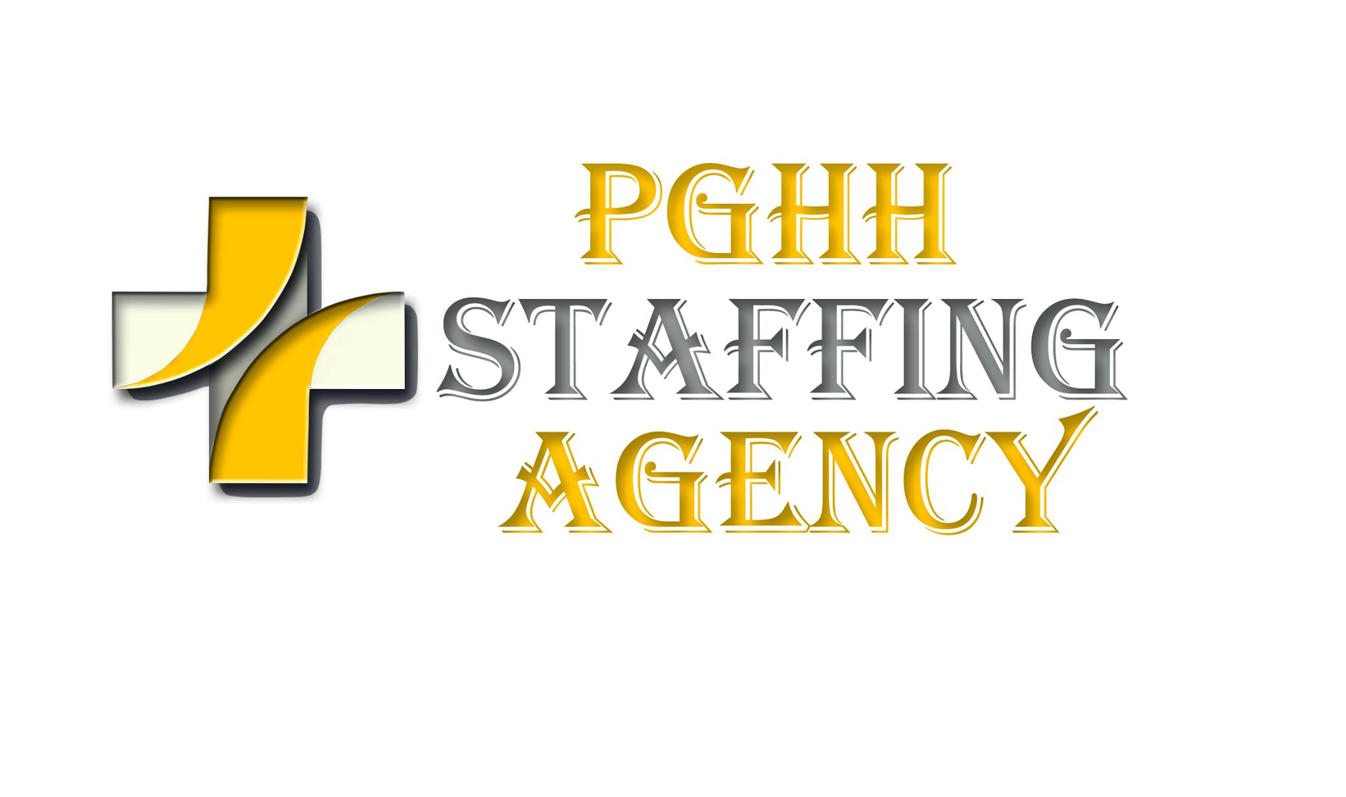
CERTIFIED NURSING ASSISTANT SKILLS CHECKLIST

Print Name____________________________________Date___________

Self | Rating Key:
0 | No experience (please print)
1 | Minimal experience/works with supervision
2 | Independent/works without supervision in most cases
3 | Senior/works at a supervisory or teaching level

Has knowledge of and can provide care and assist patients with the following tasks:
 | 0 | 1 | 2 | 3
AMBULATION
1. Crutches
2. Walker
3. Cane
4. Gait belt
PERSONAL CARE x
1. Bath:
a. Bed
b. Tub
c. Shower
2. Skin Care:
a. Back rub
b. Decubitus prevention/care
3. Dress:
a. Assist as needed
b. Use of assistive devices
4. Hair Care
5. Nail Care (fingers & toes)
a. Clean/file/trim with clippers
6. Oral Hygiene:
a. Mouth care
b. Brush teeth
c. Denture care
7. Shaving: Safety razor/electric razor
NUTRITION / HYDRATION x
1. Feeding techniques
 | 0 | 1 | 2 | 3
2. Assist with eating
3. Use of feeding assistive devices
4. Measure & record intake
5. Encourage fluids
BASIC INFECTION CONTROL PROCEDURESx
1. Hand washing
2. Universal precautions
3. Use of warm & cool applications
ASSISTING OR CARE OF PATIENT WITH BOWEL & BLADDER ELIMINATIONx
1. Bedpan / urinal
2. Bedside commode
3. Care of incontinent patient
4. Stoma care
5. Bowel / bladder training
6. Measure & record output
URINARY CATHETER CARE
1. Perineal hygiene
2. Foley catheter
3. Supra pubic catheter
TRANSFER TECHNIQUES x
1. Use of transfer gait belt
2. Weight bearing
3. Non-weight bearing
4. Mechanical lift
5. Wheelchair
TURNING / POSITION PATIENT
1. Supine
2. Side-lying
3. In chair
4. In bed
5. Use of lift sheet
COMMUNICATION x
1. Verbal
2. Non-verbal with cognitively impaired patients
RANGE OF MOTION EXERCISES x
1. Active
2. Passive
3. Combination
TAKE & RECORD VITAL SIGNS
1. Temperature
a. Oral
b. Rectal
c. Ear canal
2. Pulse:
a. Apical
b. Radial
c. Pedal
 | 0 | 1 | 2 | 3
3. Respirations
4. Blood Pressure
5. Height
6. Weight
a. Standing
b. Bed scale
c. Chair scale
SAFETY DEVICES
1. Vest restraint
2. (Soft) wrist / ankle restraint
3. Padded side rail
4. Side rails
MENTAL HEALTH & SOCIAL SERVICE NEEDS x
1. Demonstrates principles of behavior management
2. Provides emotional support to patient
3. Encourages family support
4. Encourages patients to make personal choices
5. Respects patient’s rights & dignity, including privacy & confidentiality
6. Encourages self-care as ability allows
7. Knowledge of adult, child and elder abuse reporting statutes
8. Knowledge of domestic violence and violent injury reporting statues
SAFETY / EMERGENCIES
1. Recognizes & reports safety hazards
2. Recognizes & reports emergencies and responds appropriately
3. Handles 02 safely
4. Observes, reports & documents changes in body functions, behavior
CARE OF PROSTHETIC DEVICES x
1. Limbs
2. Eye glasses
3. Hearing aids
SPECIMEN COLLECTION x
1. Urine
2. Stool
3. Sputum
UNDERSTAND AND CAN PERFORM x
1. Binders & Bandages
a. ACE bandages
b. Support stockings
2. Care of the deceased
 | 0 | 1 | 2 | 3
ASSIST THE CARE OF PATIENT WITH x
1. Diabetes
2. Cancer
3. Heart Disease
4. 02 therapy
5. Respiratory disease
6. Terminal
7. Infectious diseases

To the best of my knowledge, information provided on this CNA Skills Checklist is true and accurate. My
signature indicates that I have read this document in its entirety and understand its contents.
Print Name:

Signature:

Date:

